Network-1 Project Documentation Report
Project Number: 5
Project Name : The Distributed E-Commerce Fulfillment Network
Discussion Time : 12:15

Full Topology:
The network is designed as a Wide Area Network (WAN) consisting of four core routers (Fulfillment Center, Shipping Hub, Data Center, Corporate HQ) plus an ISP router. The topology includes switches, end devices (PCs), a DNS server, and a web server. All devices are interconnected via serial and Ethernet links, and static routing is used to achieve full connectivity. Screenshot: Full logical topology from Packet Tracer:

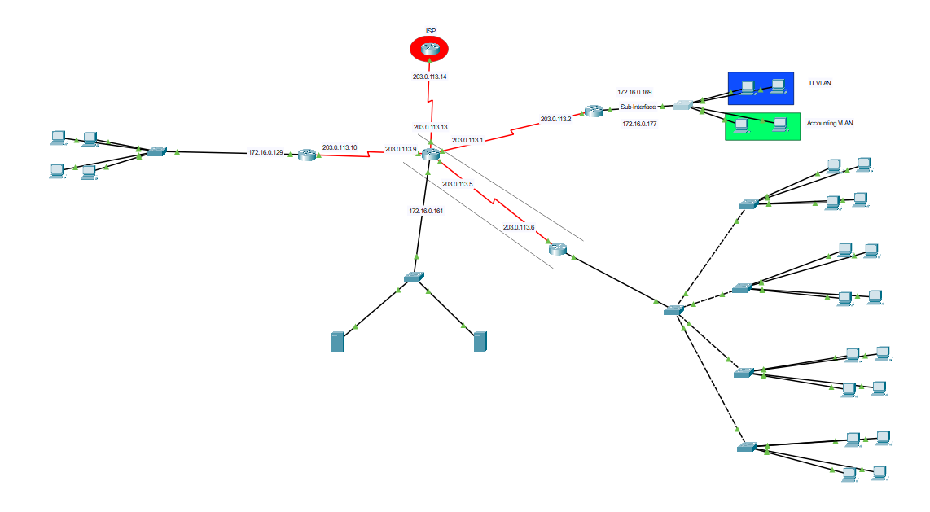

Device & Connection Specifications:
Details of all hardware and physical-layer components used in the topology.

Hardware Inventory
Device Type | Model | Quantity | Notes
Router | 2911 | 3
Router | ISR4321 | 2 | Used instead of 2911 for implementing VPN
Switch | 2950-T | 7
PC / End Host | ---------- | 98
Server (DNS) | ---------- | 1
Server (Web) | ---------- | 1

Cabling & Connection Types
Connection (From → To) | Cable Type
Between Routers | Serial
Router and Switch | Copper Straight-Through
Between Switches | Copper Cross-Over
Switch and PCs(or Servers) | Copper Straight-Through

successful ping between networks:
PC (Fulfillment Center) to Web Server (Data Center):
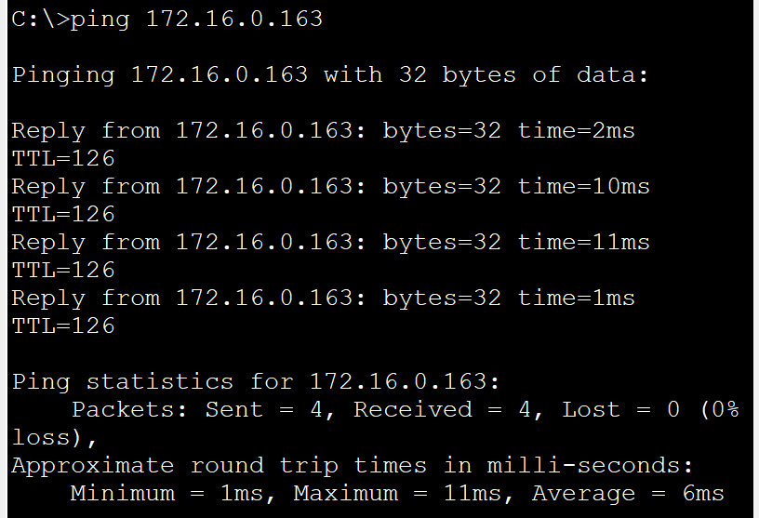

PC (Shipping Hub) to PC (HQ):
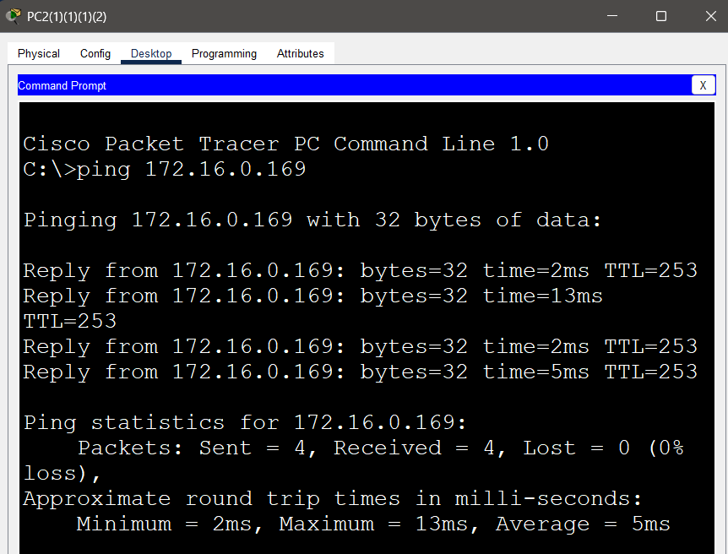

Any PC to ISP Router:
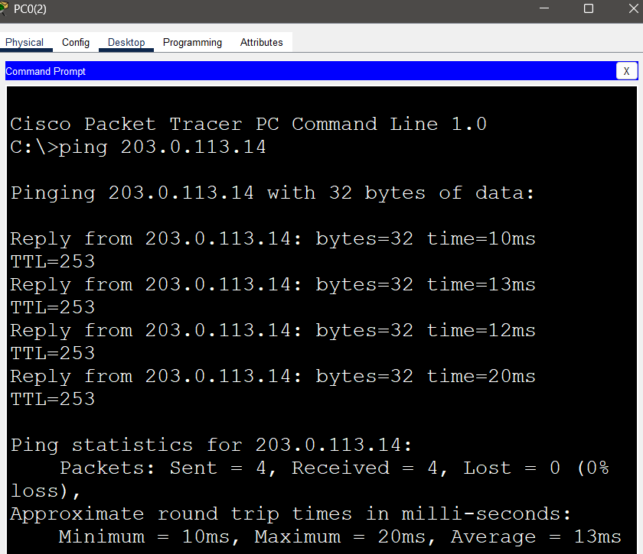
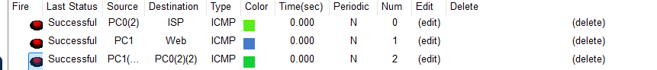

1. VLSM Chart (Internal Networks)
The private IP range 172.16.0.0/16 was divided using VLSM to meet host requirements of each LAN. The following tables summarize the subnet allocation for internal networks and WAN links.
Network Name | Hosts | Subnet | Network ID | Subnet Mask | First useable IP | Last useable IP | Broadcast
Fulfillment Center LAN | 81 | /25 (126 hosts) | 172.16.0.0 | 255.255.255.128 | 172.16.0.1 | 172.16.0.126 | 172.16.0.127
Shipping Hub LAN | 15 | /27 (30 hosts) | 172.16.0.128 | 255.255.255.224 | 172.16.0.129 | 172.16.0.158 | 172.16.0.159
Data Center LAN | 3 | /29 (6 hosts) | 172.16.0.160 | 255.255.255.248 | 172.16.0.161 | 172.16.0.166 | 172.16.0.167
HQ VLAN 10 | 3 | /29 (6 hosts) | 172.16.0.168 | 255.255.255.248 | 172.16.0.169 | 172.16.0.174 | 172.16.0.175
HQ VLAN 20 | 3 | /29 (6 hosts) | 172.16.0.176 | 255.255.255.248 | 172.16.0.177 | 172.16.0.182 | 172.16.0.183

2. VLSM Chart (WAN Links)
Link | Network ID | Subnet Mask | First useable IP | Last useable IP | Broadcast
Data Center ↔ Corp HQ | 203.0.113.0 | 255.255.255.252 | 203.0.113.1 | 203.0.113.2 | 203.0.113.3
Data Center ↔ Fulfillment | 203.0.113.4 | 255.255.255.252 | 203.0.113.5 | 203.0.113.6 | 203.0.113.7
Data Center ↔ Shipping Hub | 203.0.113.8 | 255.255.255.252 | 203.0.113.9 | 203.0.113.10 | 203.0.113.11
Data Center ↔ ISP | 203.0.113.12 | 255.255.255.252 | 203.0.113.13 | 203.0.113.14 | 203.0.113.15

Router IP configurations:
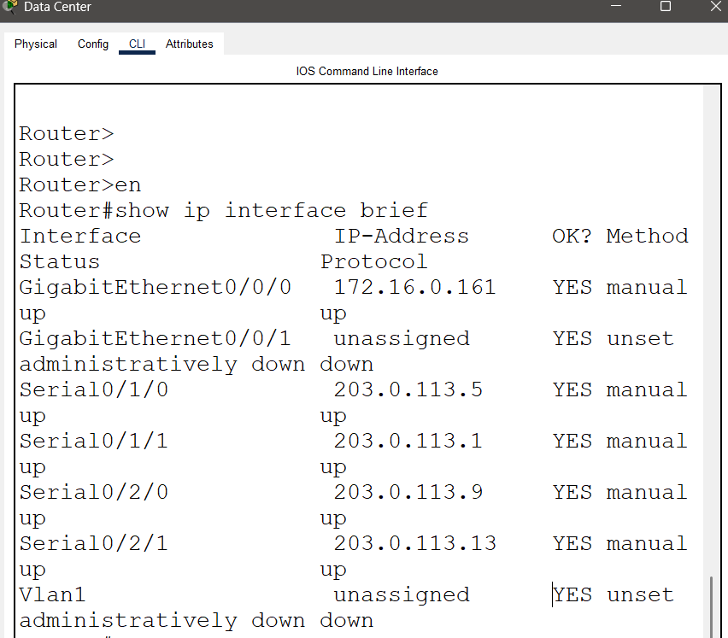
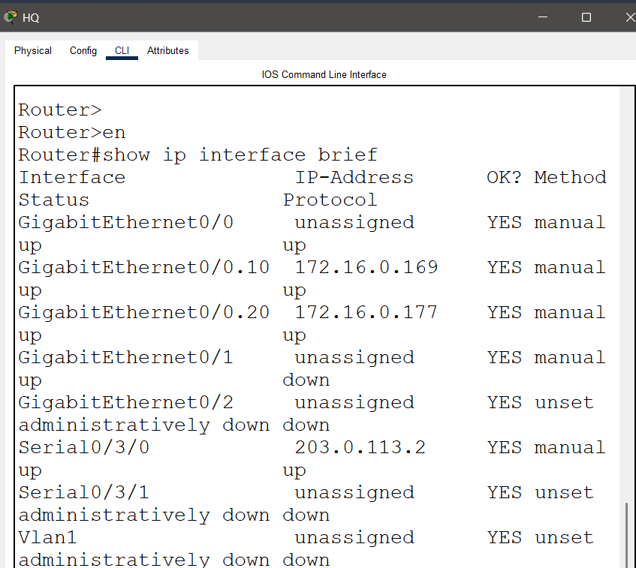
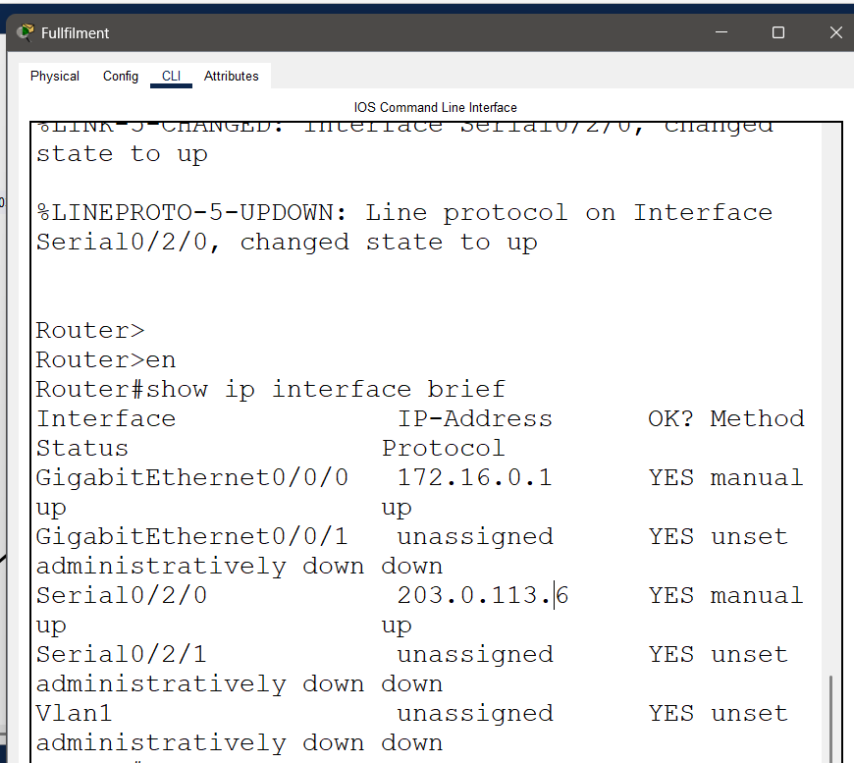

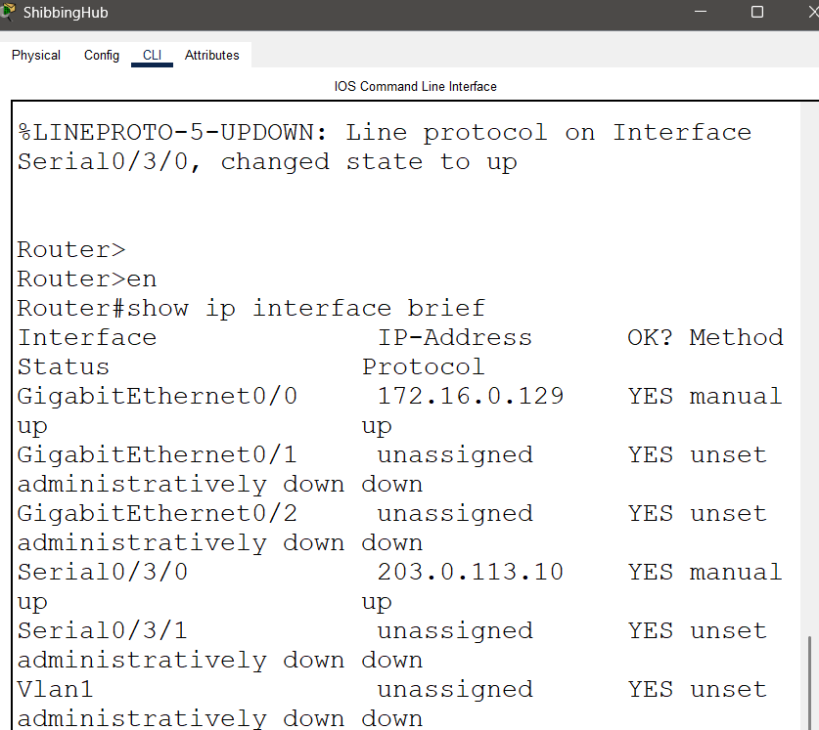

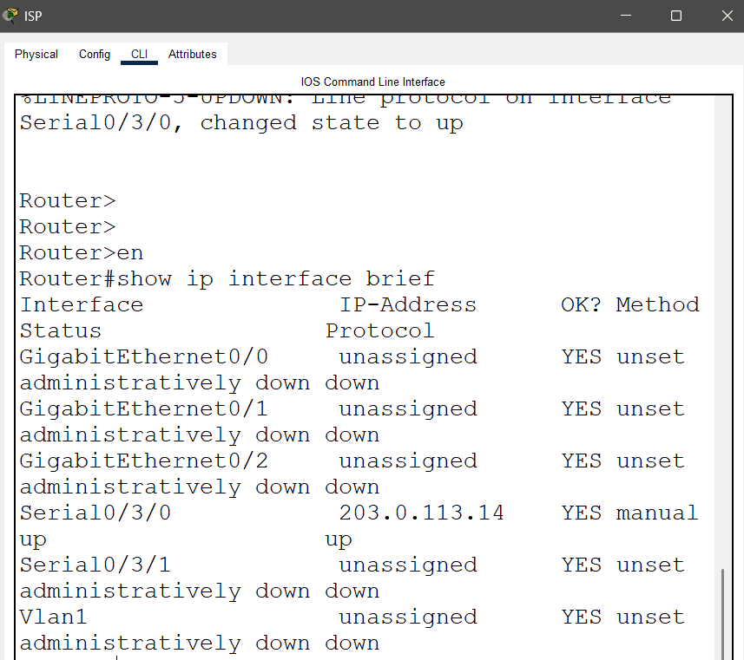

DHCP + sample PC:
DHCP pools were configured on the routers to automatically assign IP addresses to hosts in their respective LANs:
Router | Pool Name | Network | Gateway | DNS Server
Fulfillment | LAN1 | 172.16.0.0/25 | 172.16.0.1 | 172.16.0.162
Shipping Hub | Shipping-Hub | 172.16.0.128/27 | 172.16.0.129 | 172.16.0.162
Corporate HQ | Vlan1 | 172.16.0.168/29 | 172.16.0.169 | 172.16.0.162
Corporate HQ | Vlan2 | 172.16.0.176/29 | 172.16.0.177 | 172.16.0.162

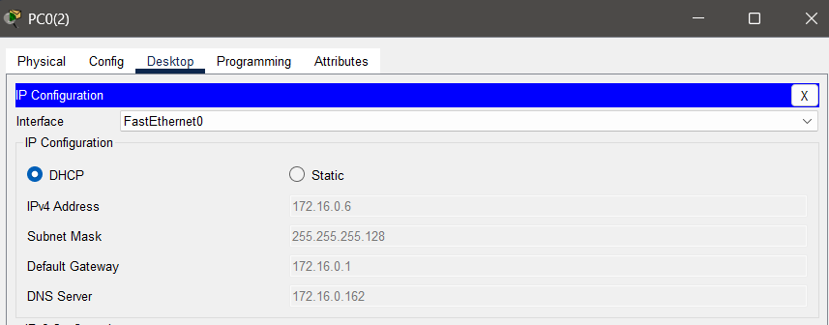

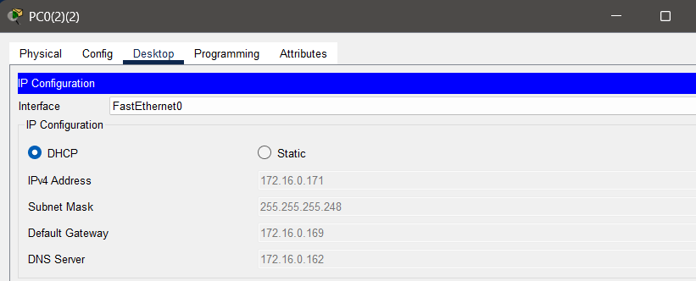

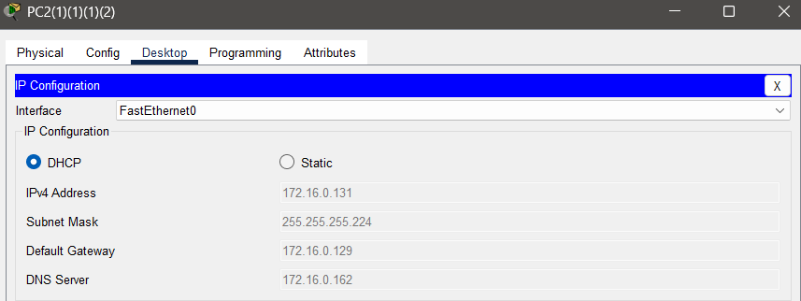

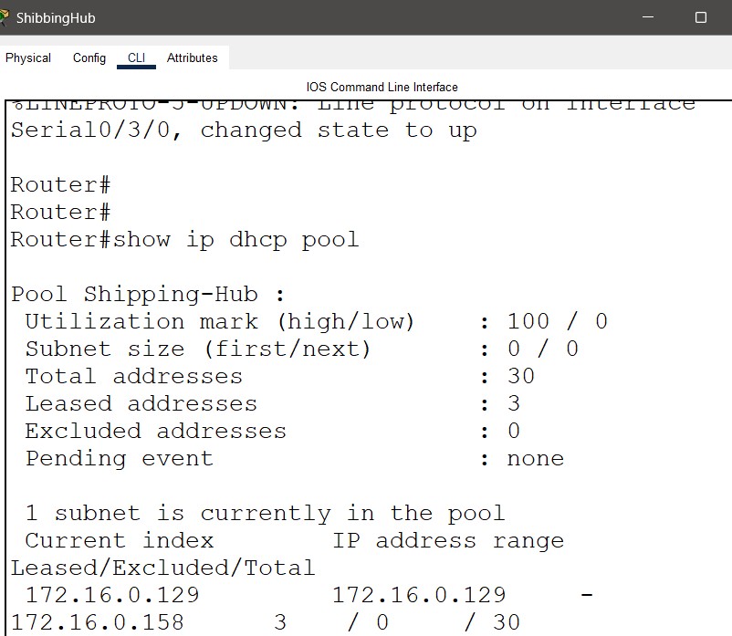
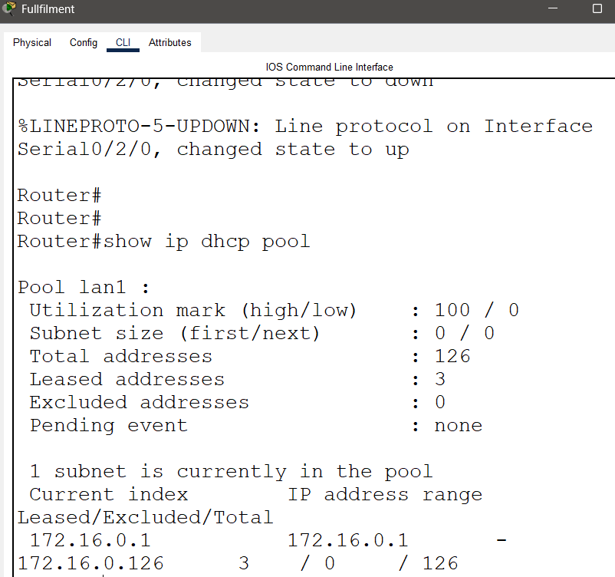

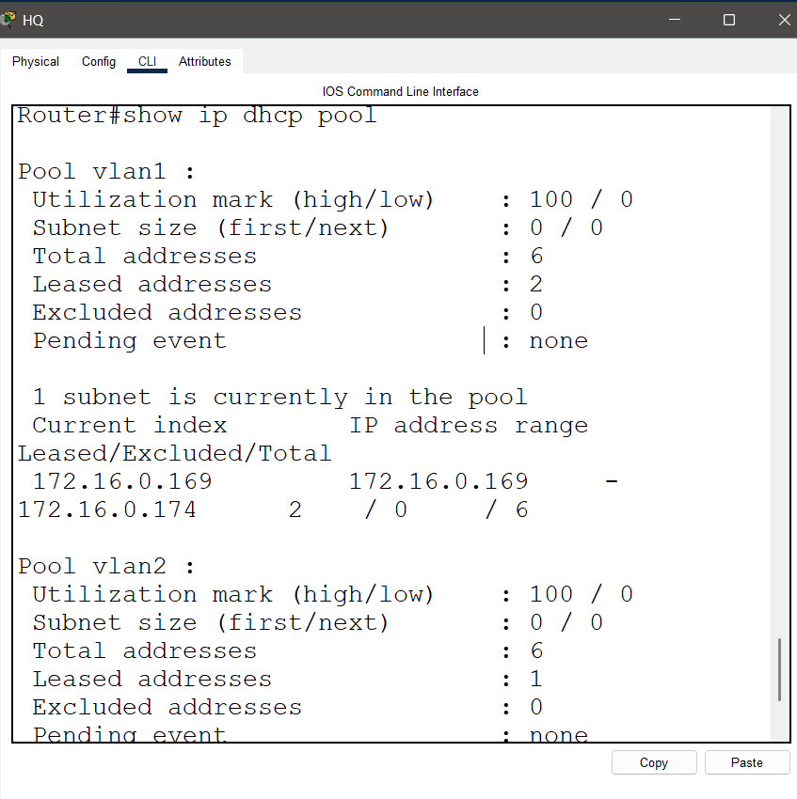

VLAN table:
On the HQ switch, two VLANs were created: VLAN 10 (IT) and VLAN 20 (Accounting). Access ports were assigned accordingly:
VLAN ID | VLAN Name State Ports
10 | IT Active f0/1, f0/2
20 | Accounting Active f0/3, f0/4

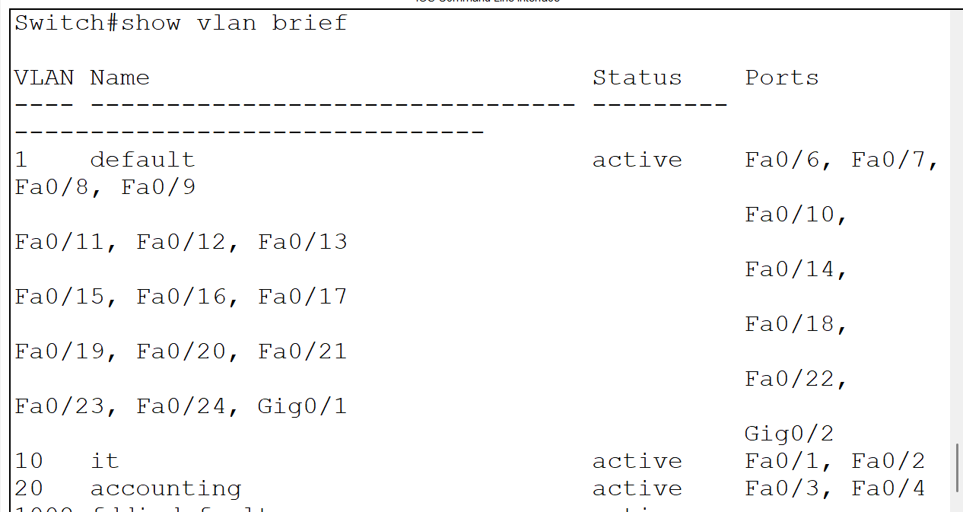

NAT translation table:
NAT was implemented on the Data Center router
Detail | Value
Router performing NAT | Data Center
NAT Type (Static / Dynamic / PAT) | Static for Web Server / PAT for End devices
Inside Interface(s) | Gig0/0/0 (Static) / Se0/1/0, Se0/1/1, Se0/2/0
Outside Interface(s) | Se0/2/1
NAT Pool / Overload Address | 203.0.113.13(Overload)
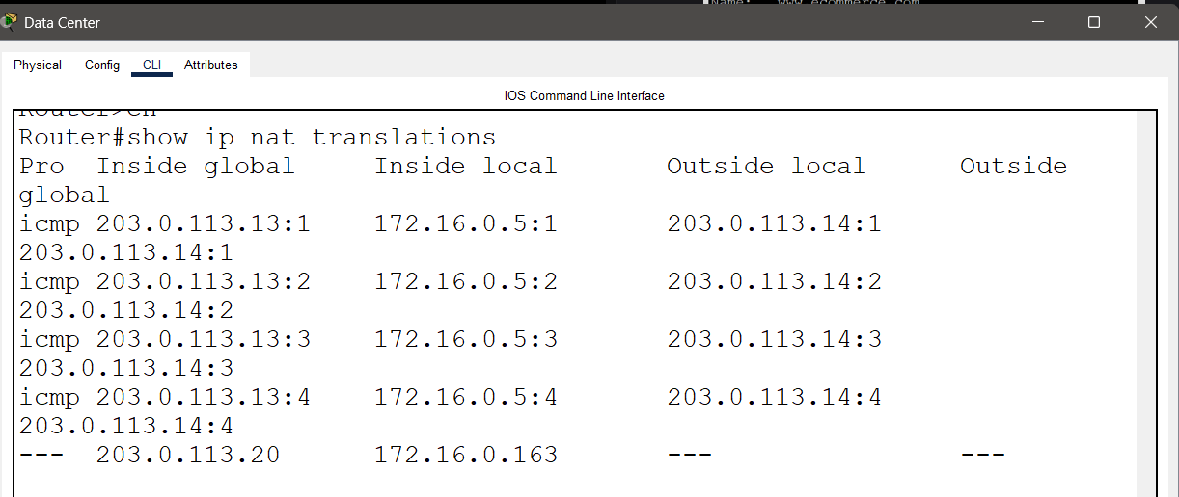

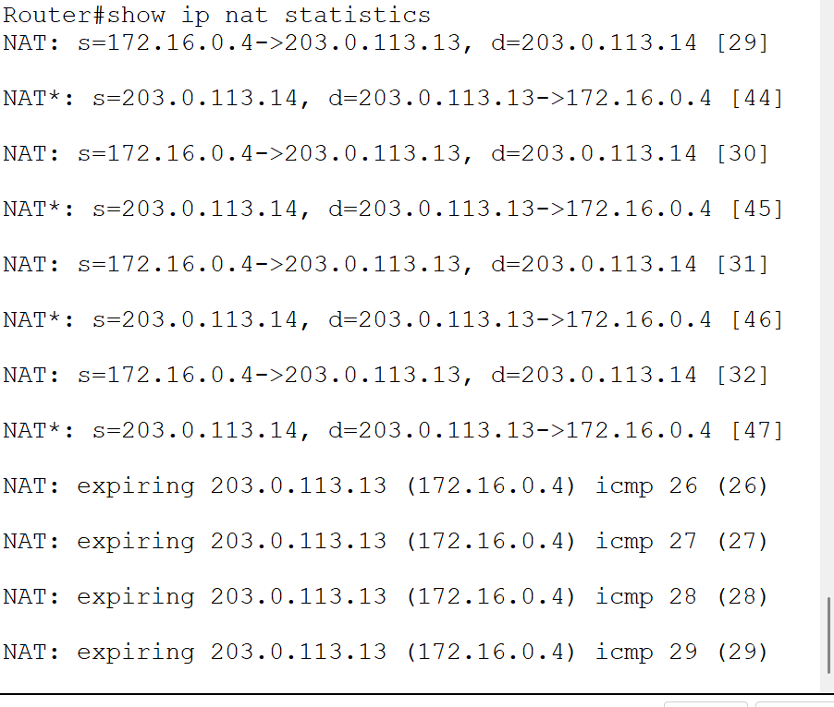

VPN status + successful ping:
A site-to-site IPsec VPN tunnel was established between the Fulfillment Center router and the Data Center router.

VPN (Site-to-Site)
Detail | Value
VPN Tunnel Start (Router) | Fullfilment Center
VPN Tunnel End (Router) | Data Center
Interesting Traffic (ACLs) | 172.16.0.0/25 and 172.16.0.160 /29
Pre-shared Key | helwan
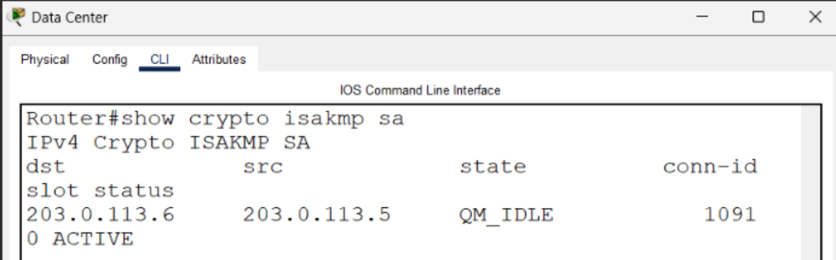

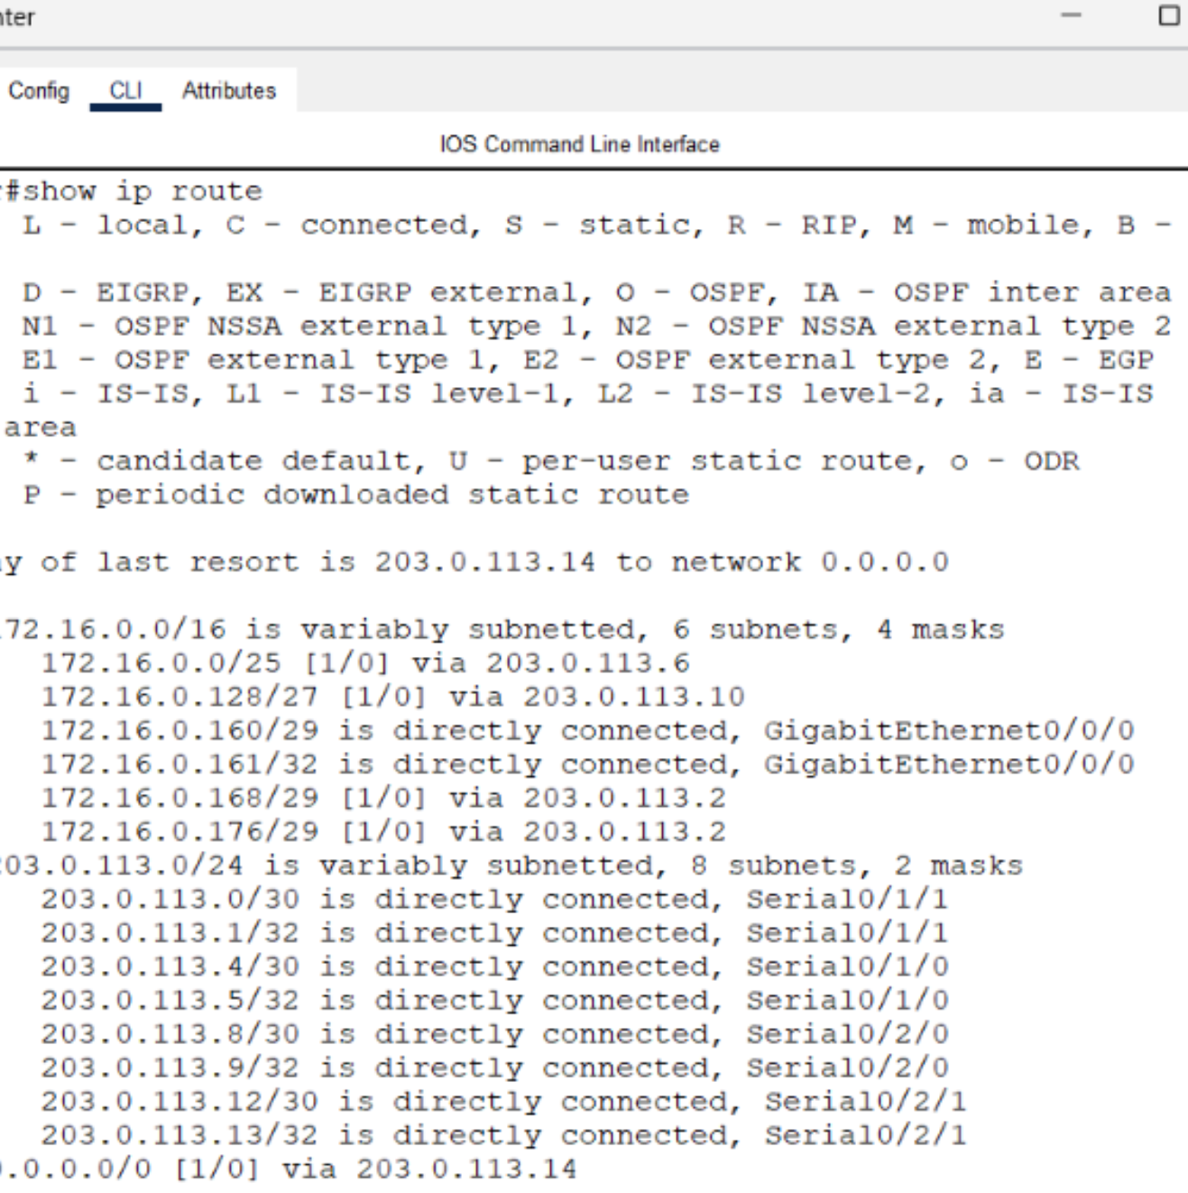

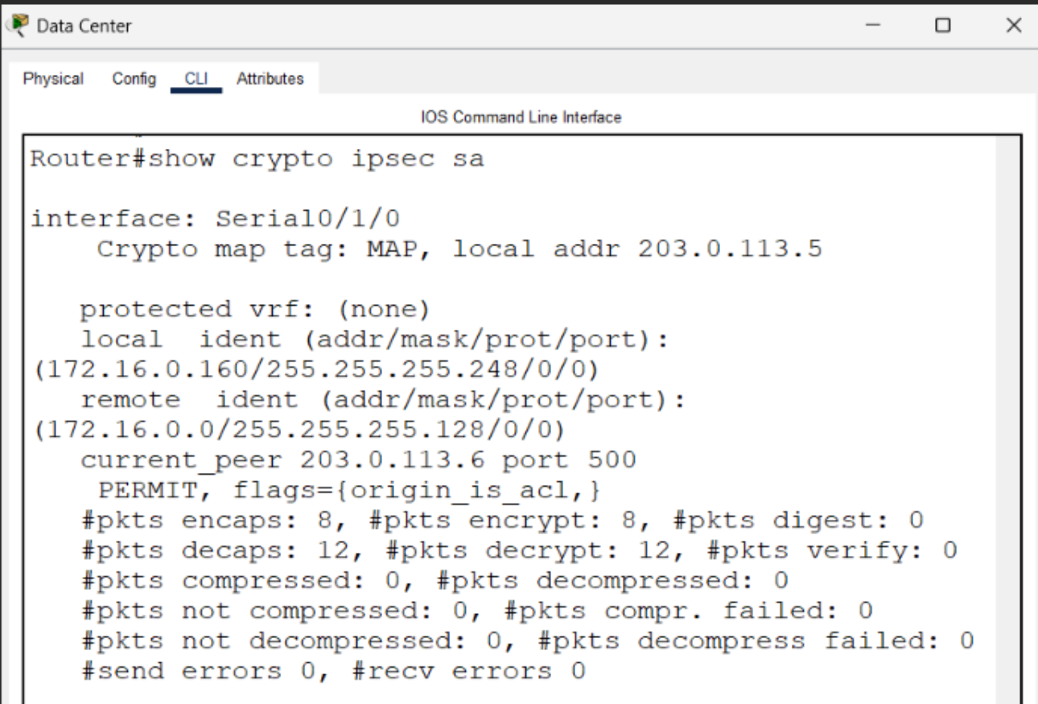

Routing table from each router:
Static routes were configured on every router to ensure reachability between all networks. Default routes were used on the branch routers pointing to the Data Center core router.

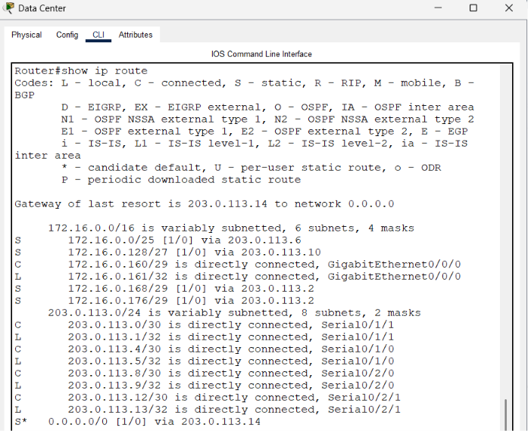

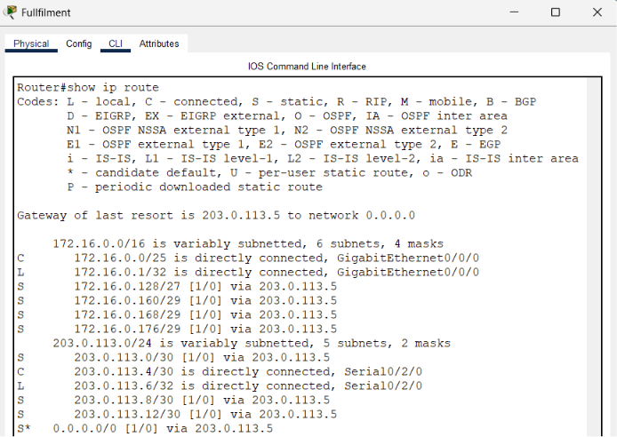

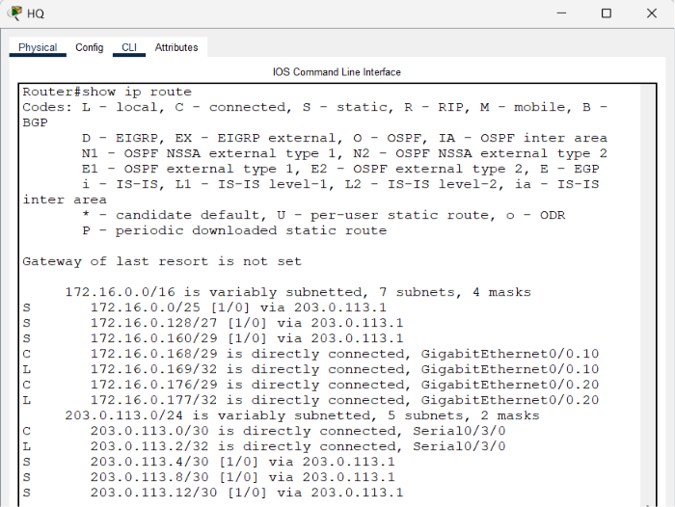

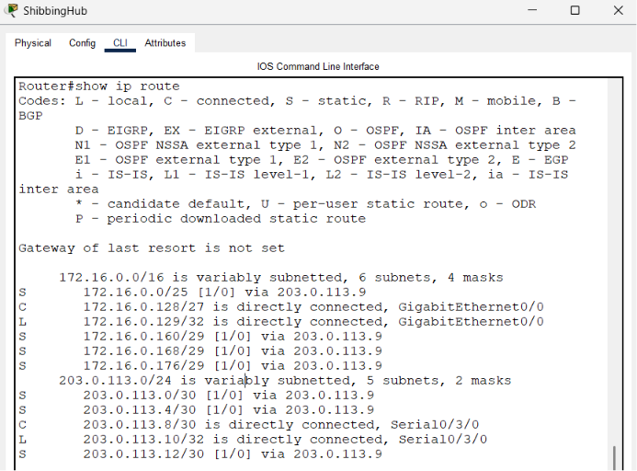

DNS & WEB Servers :

DNS Server
Detail | Value
DNS Server IP Address | 172.16.0.162
Domain Name configured | ecommerce.com
Points to (Web Server IP) | 172.16.0.163

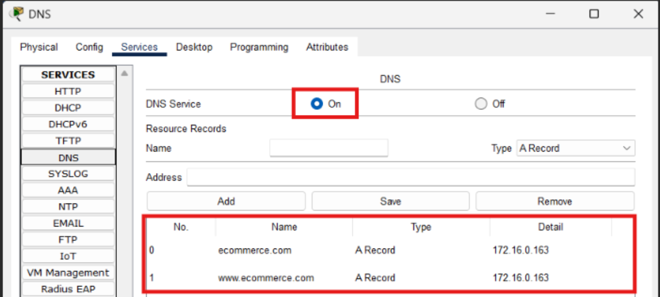
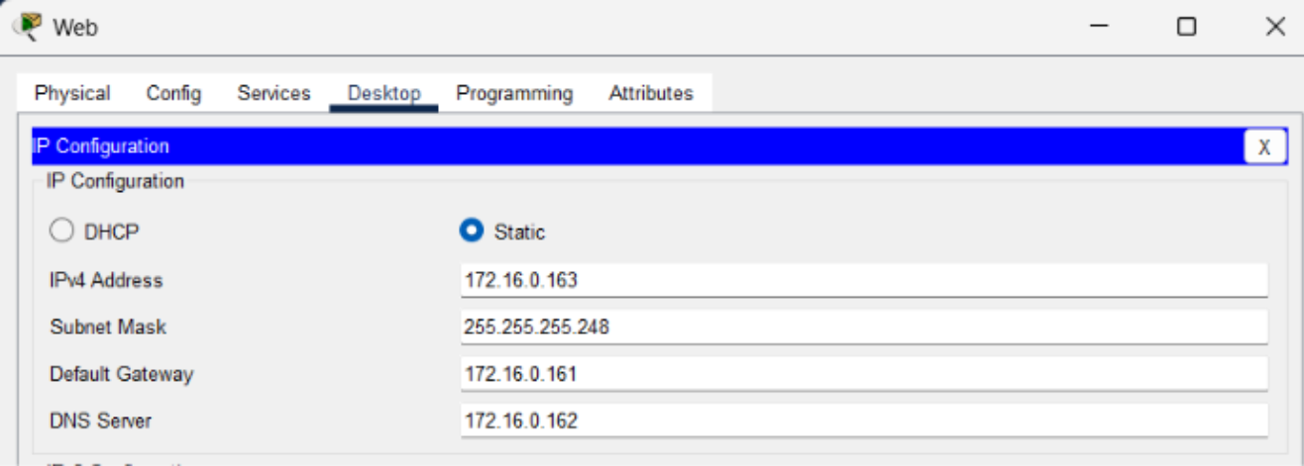
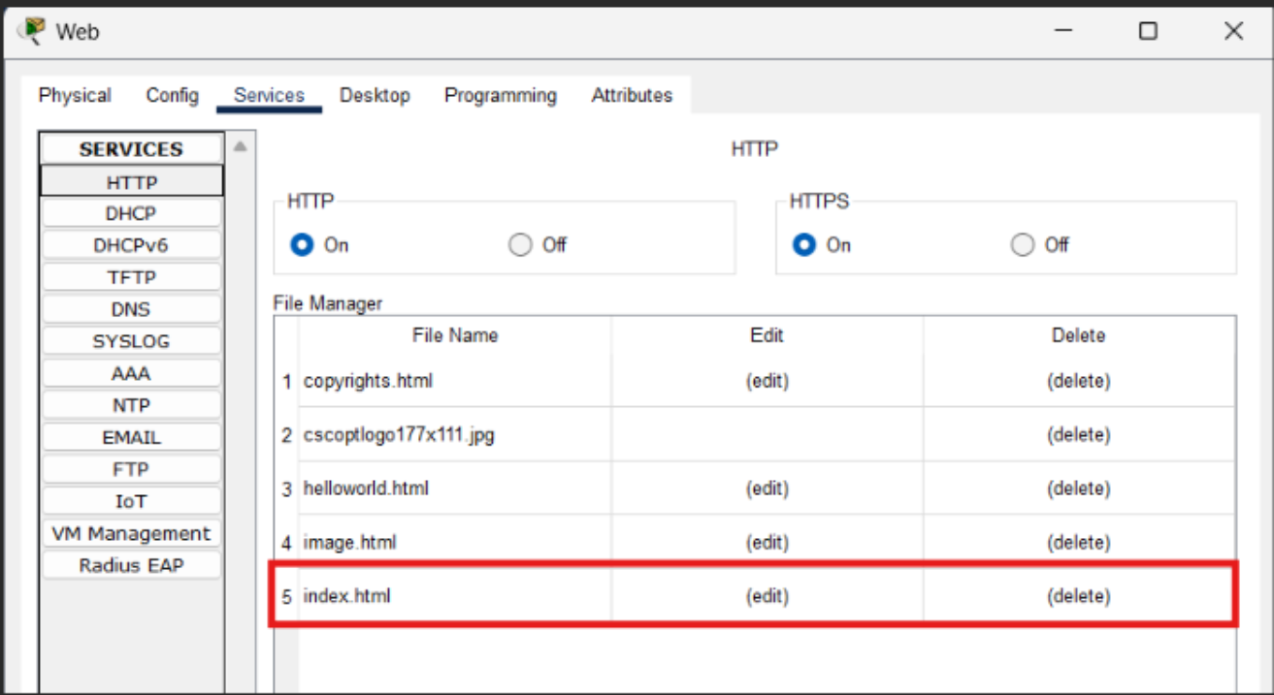
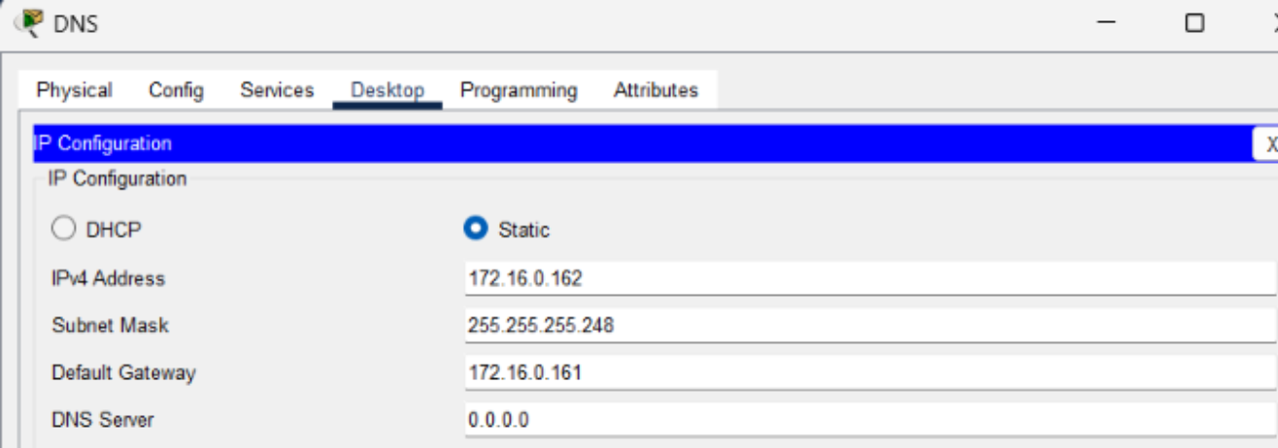
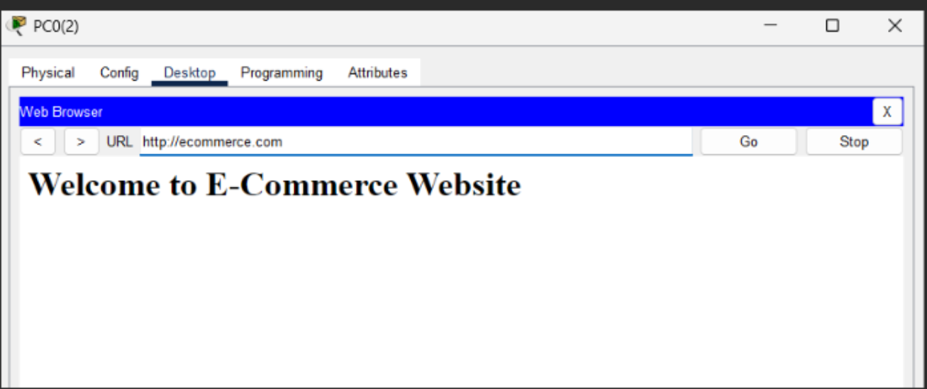

ICMP Testing:
Connectivity between all networks was verified using ICMP (ping). A successful ping from PC1 (Fulfillment Center, 172.16.0.6) to Web Server (172.16.0.163) confirms end-to-end reachability across the WAN.
Successful ping: Reply from 172.16.0.163 with 0% loss
Simulation mode: Packet path traced through routers, confirming static routes and NAT are working correctly.
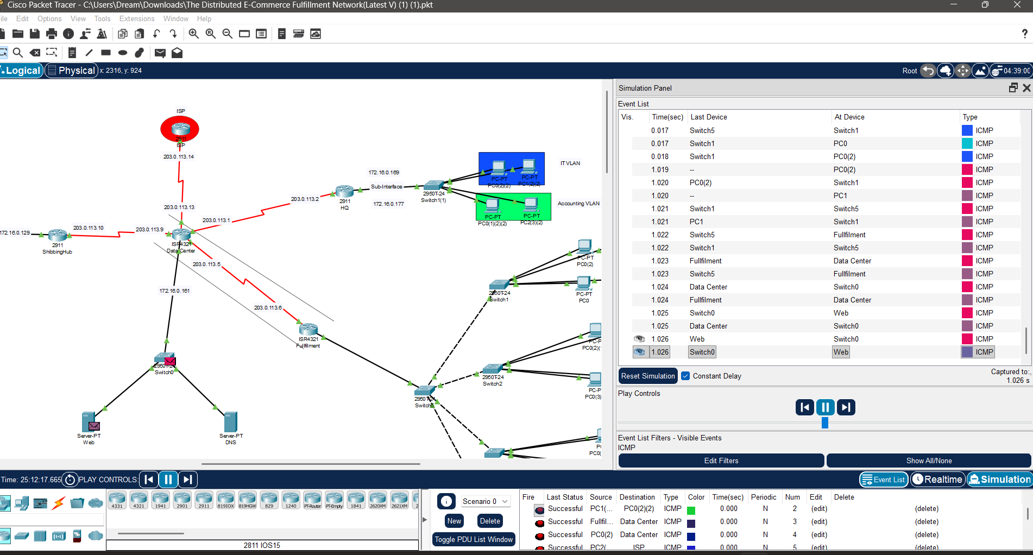

Thank you, Eng. Ibrahim, for reading all the Documentation to the end 😊.

